**Question 4: You need to add a static route on a Hyper-V host to ensure that traffic to a specific subnet is directed through a particular gateway. Explain the steps to accomplish this.?**

**Answer:**

Let's say you want to add a static route so that any traffic destined for the subnet 192.168.10.0/24 is directed through gateway 192.168.1.1.

**Steps:**

1. **Open Command Prompt or PowerShell as Administrator:**

**(**This is necessary because modifying the routing table requires administrative privileges.**)**

* Right-click on the Start button.
* Select "Command Prompt (Admin)" or "Windows PowerShell (Admin)".

1. **Check the Current Routing Table:**

**(**This helps you understand the current state of your routing table and identify the interface index you'll need to use.**)**

* We can view the current routing table using the following command:

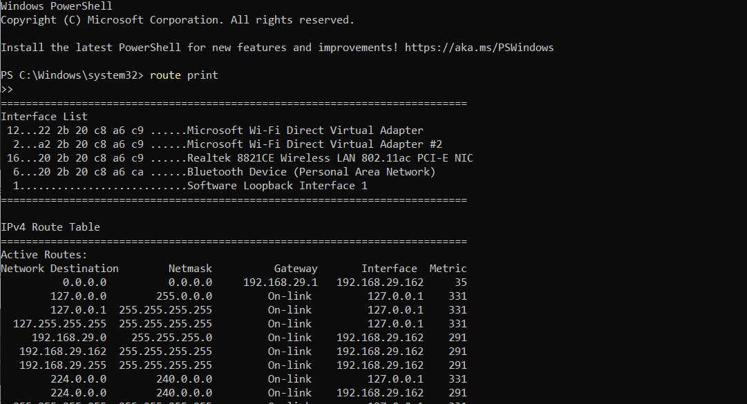

* This will display the existing routes and interfaces.

1. **Add the Static Route:**

* Use the command to add a new static route. The syntax for the command is:

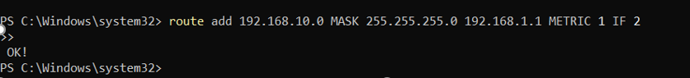

* 192.168.10.0: The destination subnet.
* MASK 255.255.255.0: The subnet mask for the destination.
* 192.168.1.1: The gateway IP address.
* METRIC 1: The metric for the route (lower values are preferred).
* IF 2: The interface index (this can be found in the routing table printed earlier).

1. **Verify the Route:**

* After adding the route, you can verify it by printing the routing table again: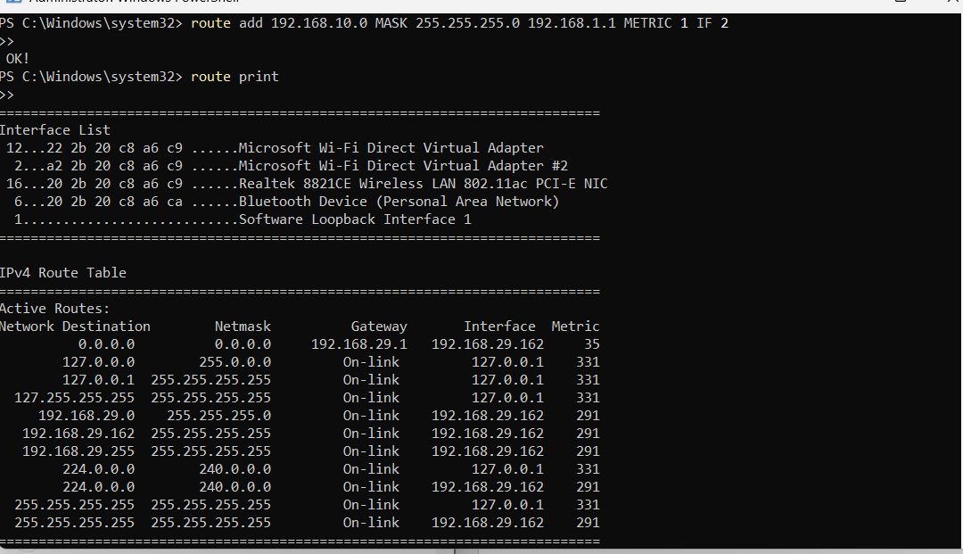
* Look for the new route in the list to ensure it has been added correctly.

1. **Persist the Route:**

* By default, the route added using the ‘route add’ command is not persistent and will be removed after a reboot. To make it persistent, you can use the -p switch: